

**Enseignante: Diana Santos**

**Étudiant.e:**

**Groupe :**

**Autonomous work #4  
  
Speaking activity**

Record a video of your presentation. Rehearse as many times as you need before recording the final version. Take into consideration the many aspects we covered in class.

We’ll watch all videos in class. But don’t stress out. You’ll have the chance to point out what you can do better for the final presentation and we, as a group will give you ideas on how to change those things you don’t like about your video.

Upload your video on Moodle or send a document with a NEXTCLOUD link (application available on you ENT at “toutes mes applis”) [ <https://ent.univ-lille.fr/> ]

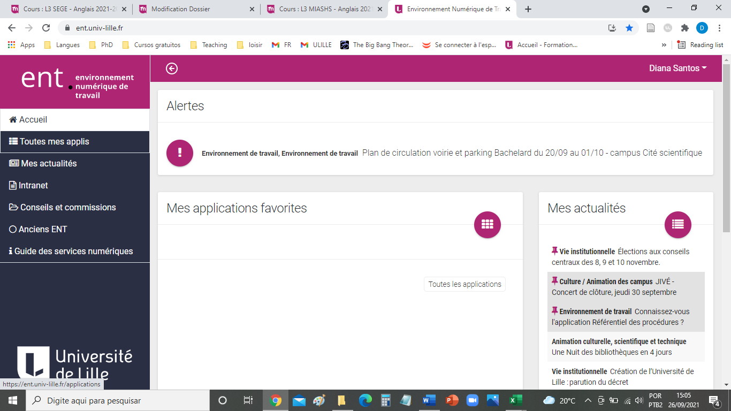

Have fun!